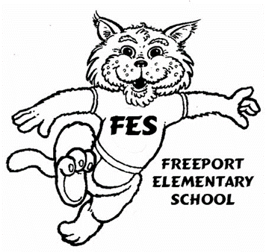
Kristin Lewis-Principal
Gay Pannell-Administrative Assistant

15381 Business 331 ● Freeport, Florida 32439
(850) 892-1210 ● Fax (850) 892-1219
Title 1 School
http://www.walton.k12.fl.us/schools/fes/index.htm

Enthusiasm for Teaching and Learning Excellence

Dear Family and/or Guardian,
Your participation in your child’s education is important to us. Because of this, we have developed a Parent Involvement Policy for Freeport Elementary School. This document explains how we plan to work with families to review and improve family programs and describes how you can participate in planning these programs. We value your involvement and urge you to take the time to read this policy. If you have any questions, feel free to call Ms. Nancy Currie at (850) 892-1211, extension 2342.
Yours truly,
Kristin Lewis, Principal
Freeport Elementary Parental Involvement Policy/Plan
2017-2018
- The policy establishes the expectations for parental involvement and describes how the school will implement a number of specific parental involvement activities.
- Freeport Elementary School (FES) believes in involving parents in all aspects of the Title 1 program. FES parents serve on the District Advisory Council (DAC) and the School Improvement Team (SIT).FES’s Parent Advisory Council (PAC) is composed of parents who help develop the Parent Involvement Policy and the Family/School Compact. Several PAC meetings are held each year at the school and district level where the Title 1 Budget is also reviewed. Surveys are sent to all parents asking for input on the school and school’s programs. The results are used in developing the school Policy and Compact for the following year and to make educational decisions.
- FES offers Parent Involvement Activities that teach parents how to help their children at home such as:
Academic Parent Events
Annual Title 1 Meeting
Pre-Kindergarten Program
School-based Parent Involvement Centers
- FES offers meetings at various times to accommodate parent schedules. Conferences and other academic events are held at night, during the day, and in the afternoon in order to provide flexible times for families. Examples would be the PTO, SIT, and SAC meetings, other school functions. Child care is provided for trainings and food is provided at events when possible.
- FES will provide materials and training to help parents and staff.
Florida Standards in hard copy and on school website
Assessment Information (local and state)
Staff Training for Effective Parental Involvement
Academic Parent Events
- The summary of the Parent Involvement Policy and Compact will be distributed to parents and located at the Parent Resource Center in English and Spanish. Written communication will be translated for parents in a language they can understand to the extent that it is practical. A complete version is available in the office and on the school website. If you would like to see a detailed copy of the 2017-2018 PIP, please contact the office at 892-1211.

